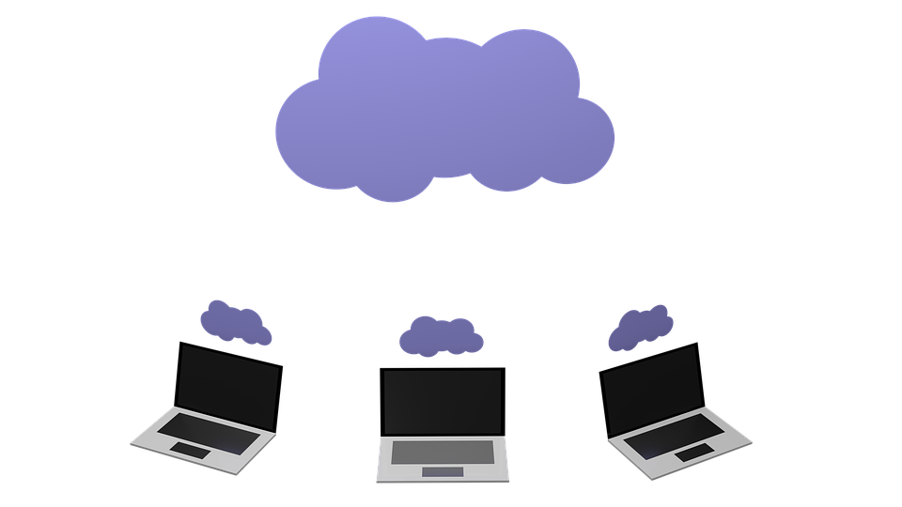
The Worst Kept Secret in Business: The Rise of PaaS

Over the last few years, cloud-based solutions have become big business. Companies that once had to rely on large scale physical installations are working with virtual software that can be installed, managed and supported remotely. This reduces deployment time and costs, and has drastically changed the way IT teams are required to operate.
This is the world of SaaS – software as a service – that many will be familiar with. But there is a new player on the block getting ready to take over in the cloud-based space: platform as a service, also known as PaaS.
For those of you who have already used SaaS or PaaS as part of your business, it should hardly be a surprise that demand for PaaS is expected to increase considerably over the next few years. Global demand for PaaS was valued at $2.11bn in 2015 and is expected to generate revenue in the region of $9.12bn by the year 2021.
This has led to an unprecedented and improved performance on the stock market for numerous PaaS providers. It has even been reported that for one provider, revenue spiked as much as 82%, much to the surprise of management and markets alike. It is expected that this trend will continue and most likely increase in the future and that we will shortly see PaaS solutions being implemented by businesses around the globe.
But behind the success stories, what are the key differences between SaaS and PaaS? And which could be better for your business?
What is SaaS?
Software-as-a-service represents the largest share of the cloud-based market; using the internet to deliver apps that are managed by a third-party vendor, with the interface accessed on the clients’ side. This allows them to be run from any web browser without the need for downloading or installing software.
What are the advantages?
As mentioned, SaaS takes away the requirement to install and run applications on individual computers, allowing businesses to streamline their maintenance and support by handing control over to external vendors.
Notable examples
The most notable example of this is Google Apps for Enterprise, which along with other powerful cloud-based software, such as cloud based budgeting software, allows businesses to seamlessly integrate and improve their services.
What are the disadvantages?
A key challenge is faith in both the cloud and outsourced providers. Business owners are required to put their faith in external teams due to not having a dedicated internal team to support them. This a leap of faith that continues to pose too much of a risk for some business owners who prefer to retain overall control over all aspects of their business.
For companies that operate across borders or that handle sensitive information, there is also the worry about the potential vulnerabilities of offsite servers and the lack of control that presents as well as the geography-based data protection rules that may or may not apply.
What is PaaS?
Platform-as-a-service is a type of cloud computing that provides developers with a platform and environment to build apps and services over the internet. It can be accessed anywhere in the world and is hosted in a cloud and accessed via a standard web browser.
What are the advantages?
A lot of the time PaaS services consist of preconfigured features that can be applied by users; these can either be included if they meet the needs of the developer, or discarded if this is not the case. There is also the added incentive that those using the service can benefit from the sharing of infrastructure, resulting in lower costs.
Notable examples
The most well-known example is Microsoft Azure, which is an internet-scale cloud service hosted by the Microsoft data centers, providing an operating system and a developer service that can be used individually or together.
If have used it yourself then you will be aware that Azure can be used to build new applications to run within the cloud or to enhance existing applications which benefit from existing cloud-based capabilities.
So, is PaaS just another cloud based piece of software?
A key consideration to remember is the fact that we are currently witnessing PaaS gain substantial momentum in comparison to other cloud-based solutions; this is likely due to the fact that it has substantial benefits for both global companies and small businesses, allowing them to use their IT budgets more effectively.
This is mainly due to the fact that PaaS can provide server management, hosting and deployment in one package, freeing up money that could would be allocated technical or support costs to increase development budgets – this means more or higher calibre developers getting your business moving and much faster innovation. At time when it essential for businesses to develop their own apps to keep up the shift in consumers’ expectations, it is easy to imagine the benefits of the freedom PaaS enables.
This is where PaaS is an ideal and agile solution for businesses of all sizes and can return a substantial ROI in the medium-to-long-term: as your business grows and takes off, PaaS makes it significantly cheaper, faster and easier to scale up. Rather than rebuilding your real-life platform to manage new volumes, you just change your PaaS options and accelerate at the pace you want to.

